

**BCI2323 – WEB DEVELOPMENT**

**Group Project Report**

**TITLE:**

**Online Bookstore System**

**Group No.: 6**

|  |  |  |
| --- | --- | --- |
| **SI** | **Group Members’ Name** | **Matric ID** |
| **1** | **BENOUAHMANE RAMI** | **CF23001** |
| **2** | **SAEED MOHAMMED KHALED ABDULAZIZ** | **CF23006** |
| **3** | **ALMASHGARI ABDULRAHMAN SALEH SALEM** | **CF23002** |
| **4** | **BASAIF AHMAD ISLAM AHMAD** | **CF23003** |

Contents

INTRODUCTION 3

OBJECTIVES 4

PROPOSED SOLUTION 5

FLOWCHART 6

GANTT CHART 7

DATABASE TABLES 8

INTERFACES AND CODES 16

INDIVIDUAL PLANNING 41

MEETING REPORT (LOGBOOK) 46

# INTRODUCTION

In the digital age, internet sites are a necessary component of our daily lives. As the e-commerce business continues to expand at a significant rate, individuals are becoming more dependent on the internet and online shops to search, compare, and buy goods, all without leaving their location. This has been particularly in the book business where it may be unproductive and a waste of time to visit the bookstores physically, when one is aware of the title, author or genre that he or she is interested in.

It is based on this need to want to have a quicker, efficient and convenient way of browsing through books that the Online Bookstore System was created. It is a website that caters to helping customers find a specific book genre or author and order the book to be delivered to their designated area. The users no longer need to physically search the shelves or get confused with the stock as they can now see live information and process transactions using a user-friendly interface.

The aim of the project is to simulate the key functions of a bookstore, but with the benefit of digital technology in order to enhance speed, accuracy, and usability. It has integrated the required aspects of web development like front-end development, backend processing, and database incorporation to present a working and stable solution that can be employed in the administration of contemporary bookstores.

OBJECTIVES

The online bookstore has the following as some of its key goals:

* Creating an online book shop that would have a simple/user-friendly interface in which one can browse through the book and search using the various categories and genres.
* Ensuring the applications support user registration, logging into the accounts, as well as account management with no insecurity by adopting secure user authentication.
* Put in place a safe and sound payment gateway to transact and ensure the customer is secure with his details.
* Facilitate the functions of its users by offering them the option to review their order history, monitor current orders, and modify their personal details.
* To Include a system to review where a customer rates and comments on books to assist other future customers to access information to make the right choice.
* Design the desktop and mobile-oriented site to provide an optimal user experience.
* Offer an adequate database management framework to retain and handle user, book and order data in a suitable way.

# PROPOSED SOLUTION

The suggested course of action is establishing an online bookstore that will provide the services of casual readers and book lovers because of the growing popularity of an effortless and safe online shopping experience. This platform will provide its users with a convenient browsing environment, secure payment platform, and those features that will be required to support the whole shopping experience. Several key features of the proposed solution could be listed as follows:

* **Account Administration and Registration**:  
   Open accounts, sign in, and edit data.
* **Checkout, Shopping Cart**:  
   They can add several books in their cart, view the amount they are to pay, and complete a simple check-out procedure where they agree on how to ship, as well as how to pay.
* **Order Tracking**:  
   Monitor their buying experience, starting at the time of processing, and ending when their delivery was made.
* **Database Management**:  
   A relational database to handle user accounts, book listings, orders, and reviews.
* **Responsive Design**:  
   A responsive site, which offers a smooth experience to a user.
* **Ratings and Reviews of Books**:  
   The users leave comments, reviews, and stars on the books purchased so as to assist other users on whether to get copies of books or not.

# FLOWCHART

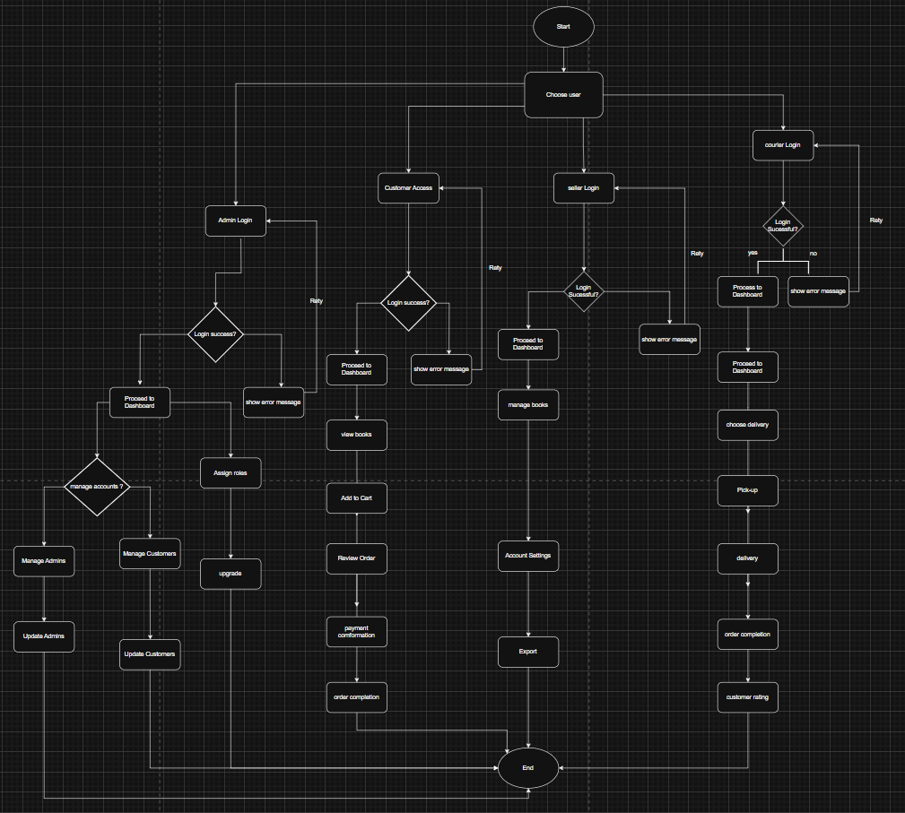

# GANTT CHART

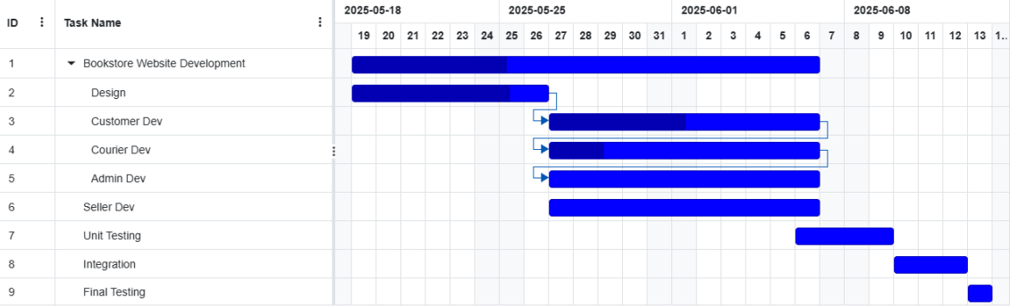

# DATABASE TABLES

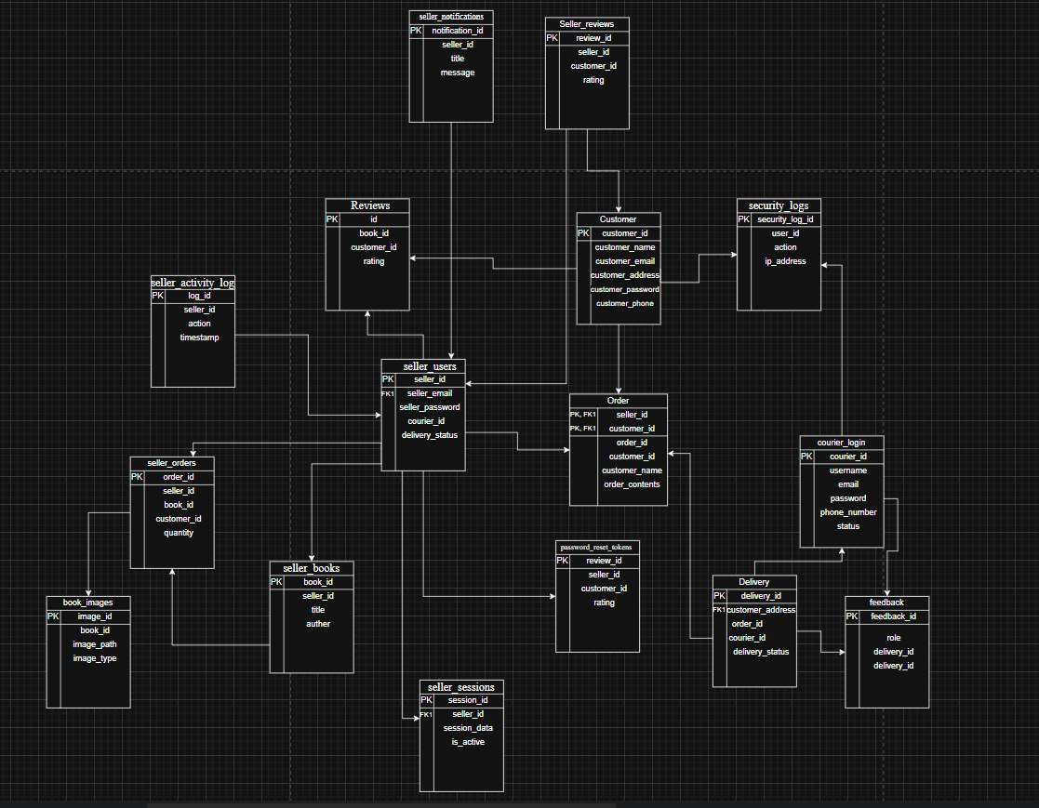

The bookstore database contains the following tables:

1. book_images

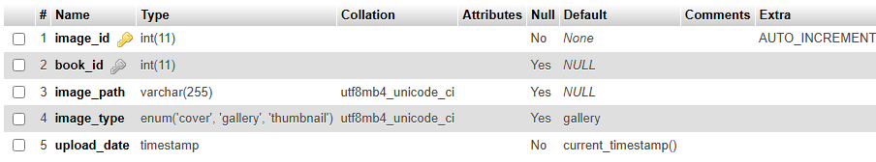

1. Customers

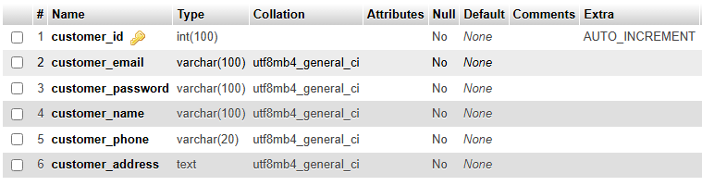

1. Deliveries

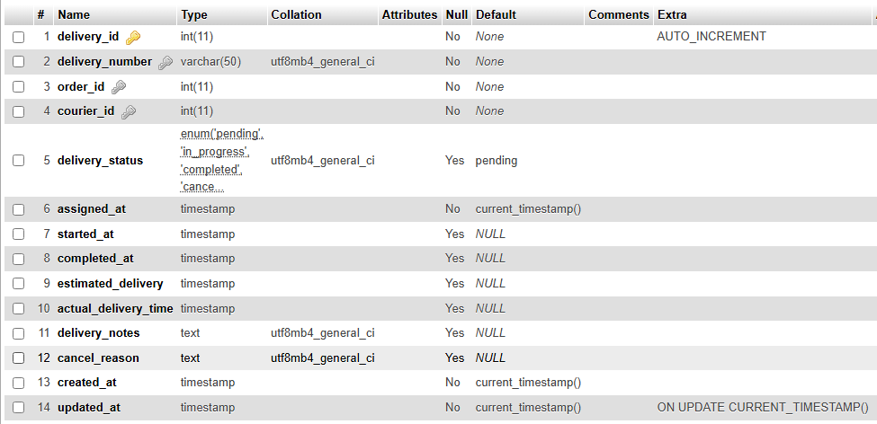

1. Feedback

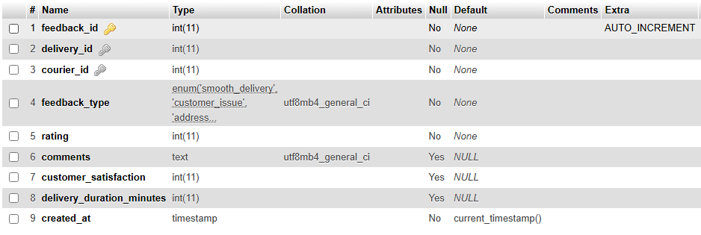

1. Orders

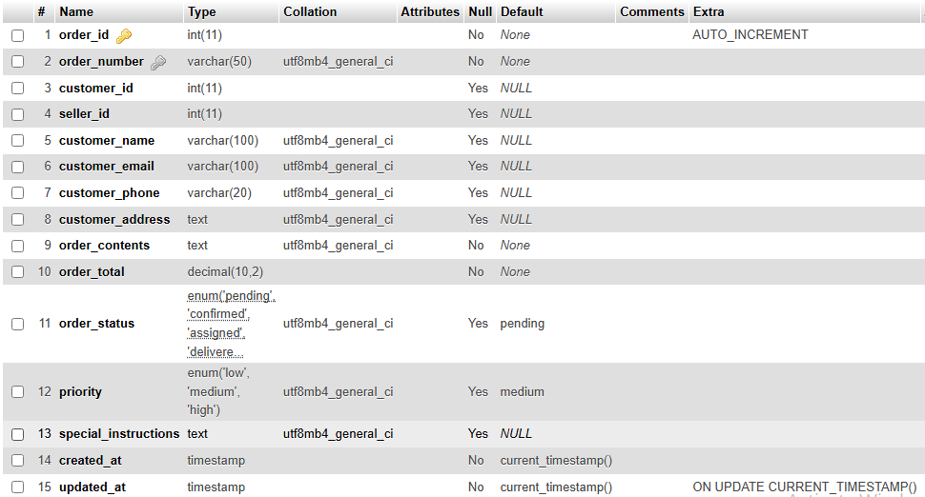

1. password_reset_tokens

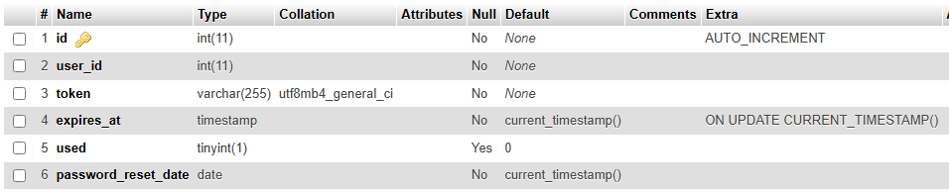

1. Reviews

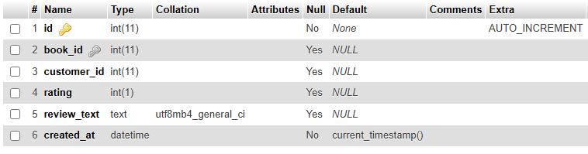

1. security_logs

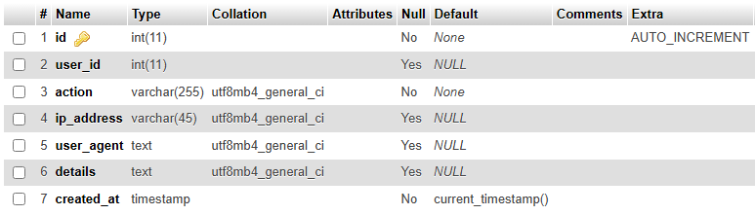

1. seller_activity_log

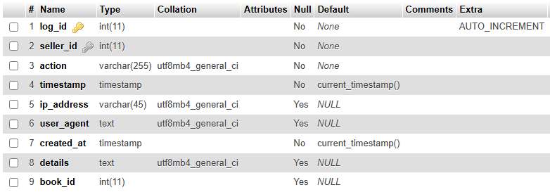

1. seller_books

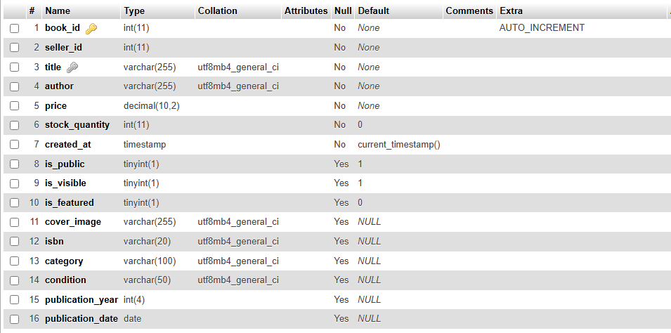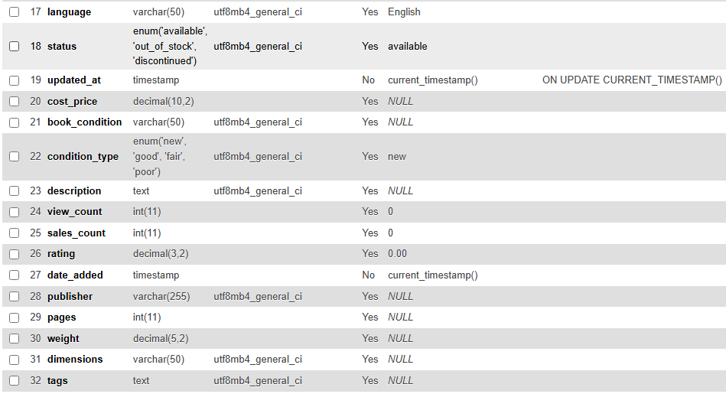

1. seller_notifications

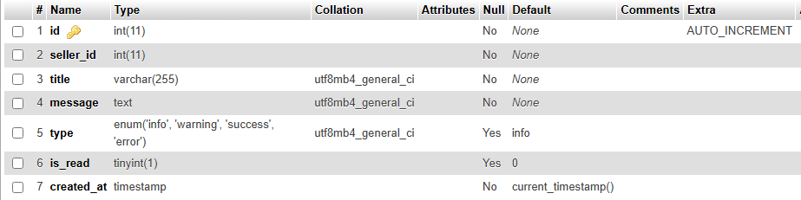

1. seller_orders

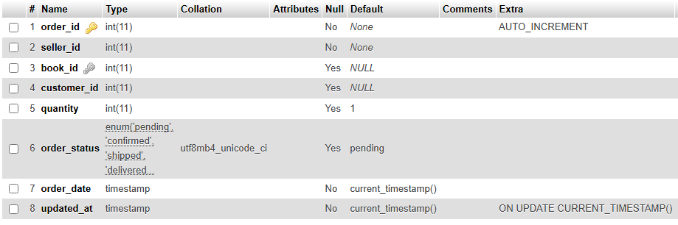

1. seller_reviews

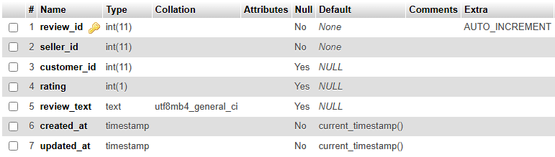

1. seller_sessions

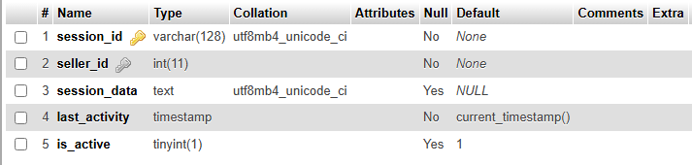

1. seller_users

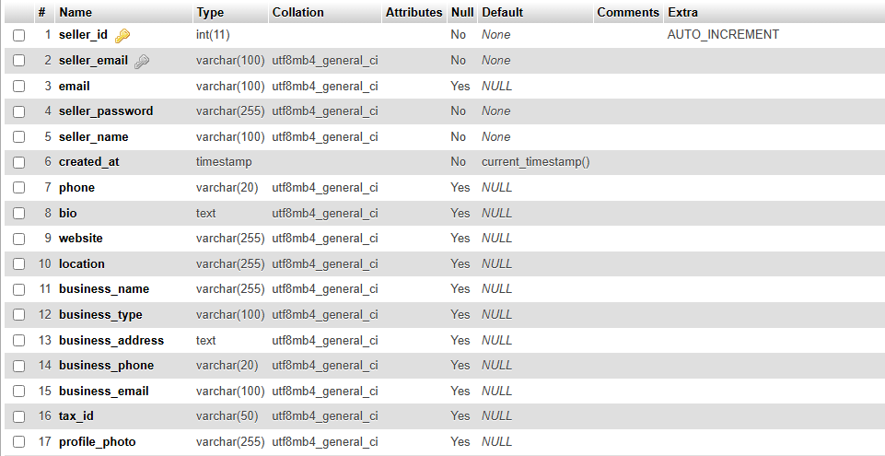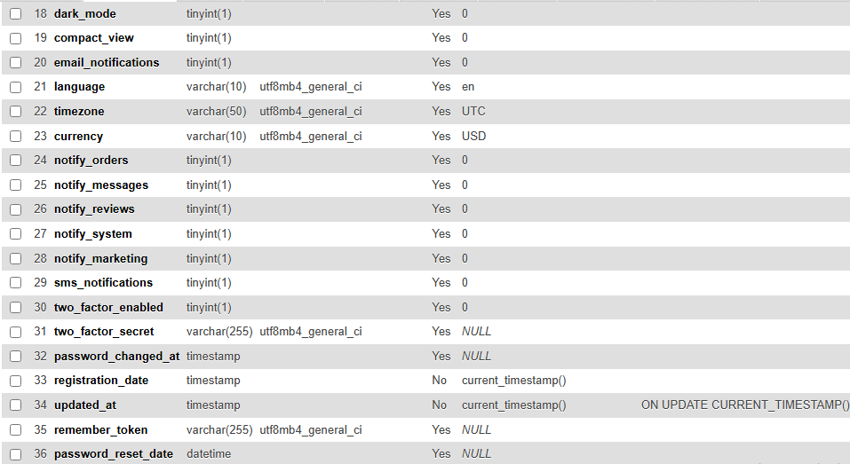

1. Users

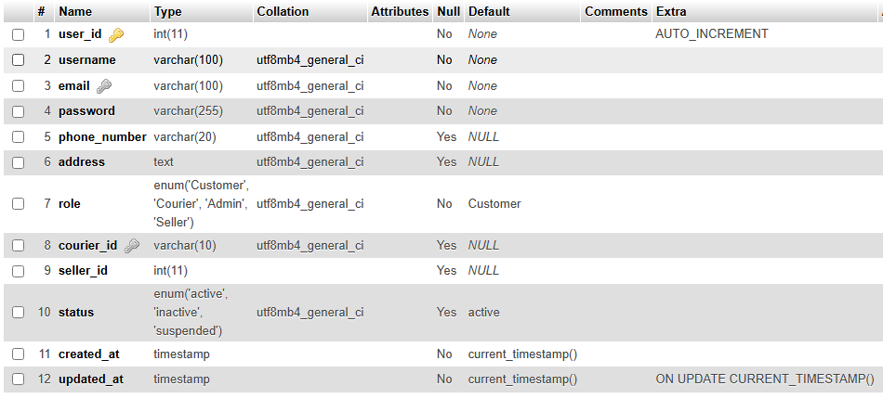

# INTERFACES AND CODES

## Admin Interface

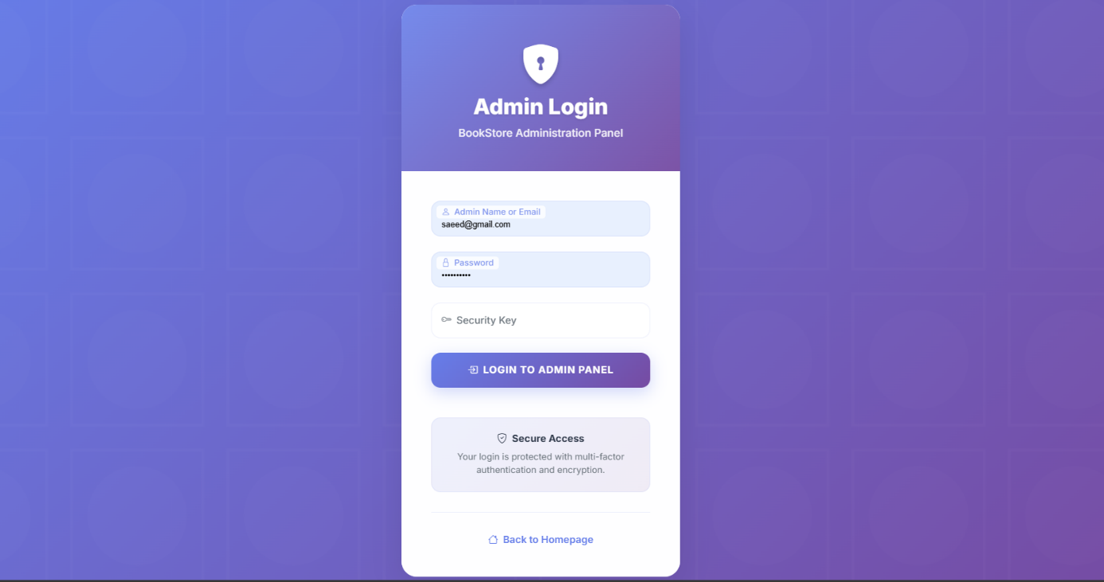

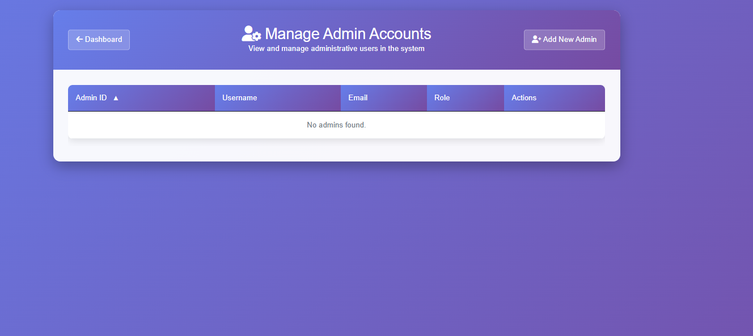

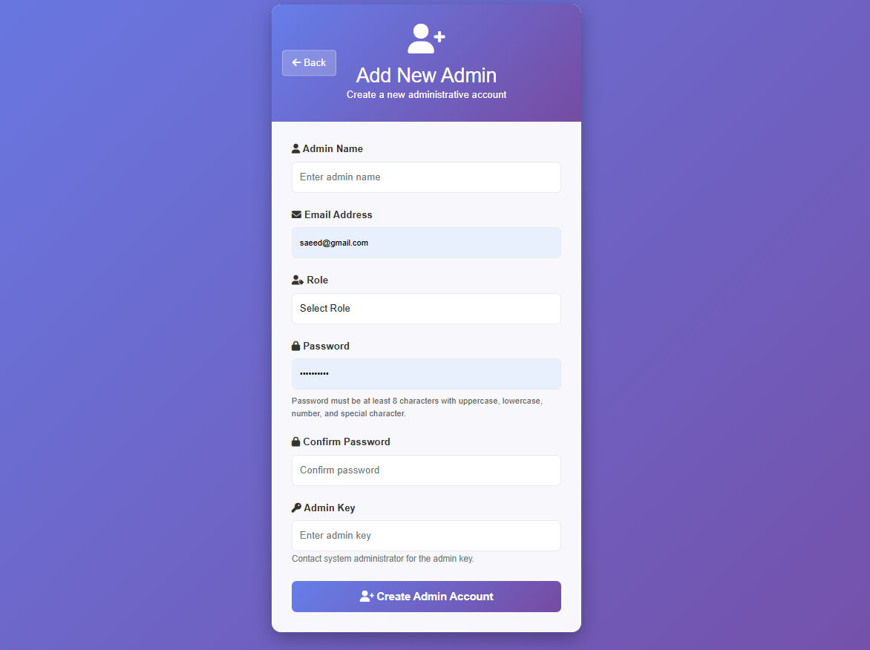

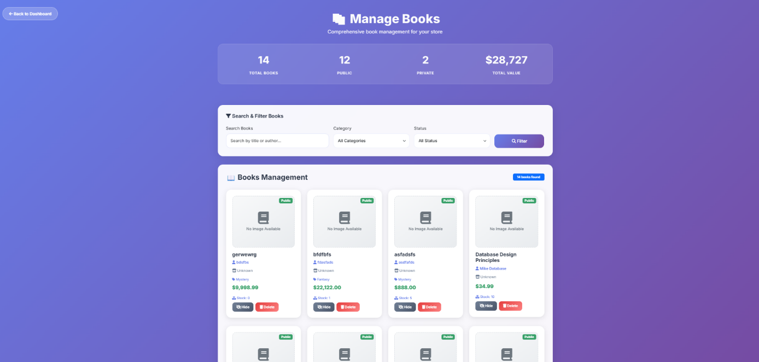

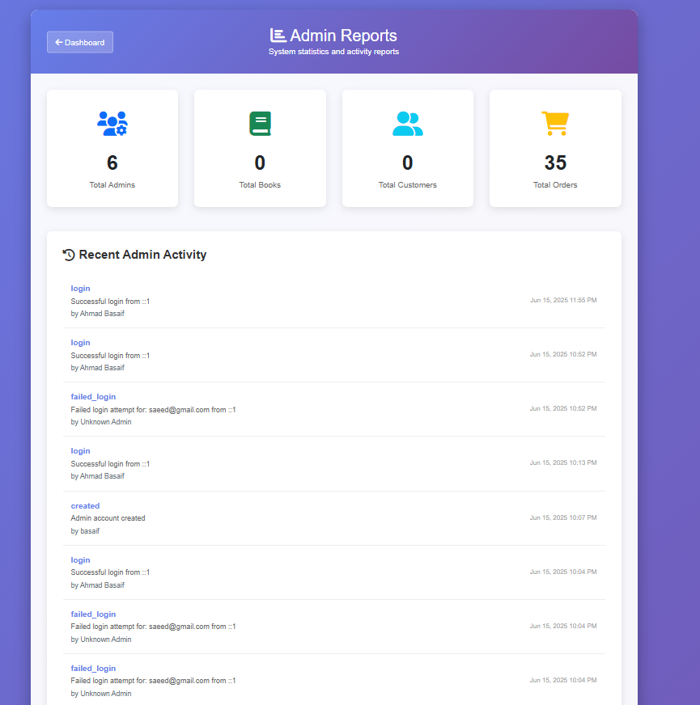

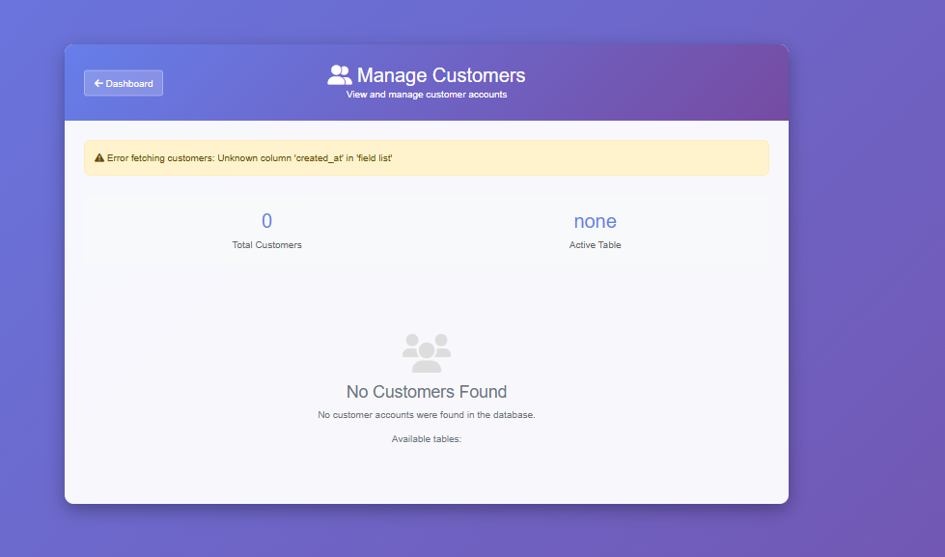

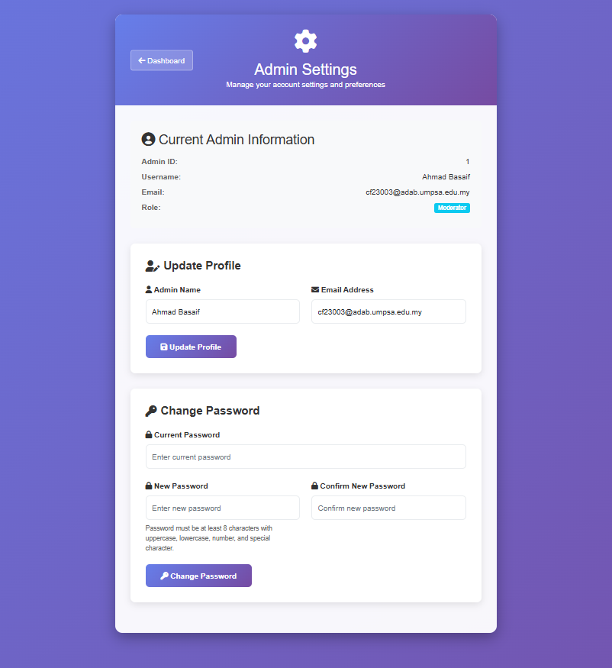

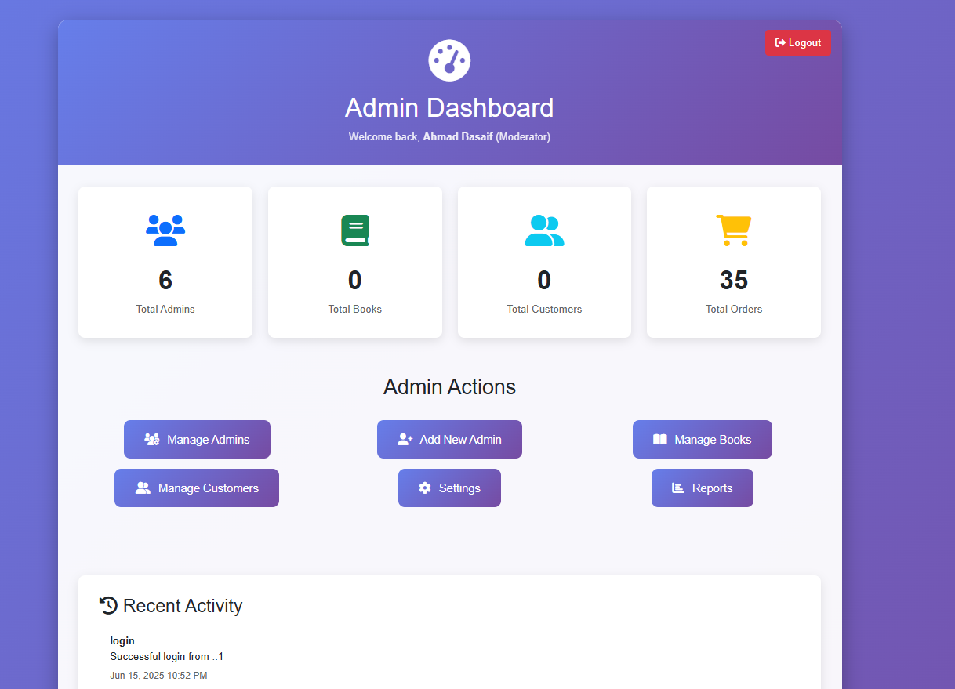

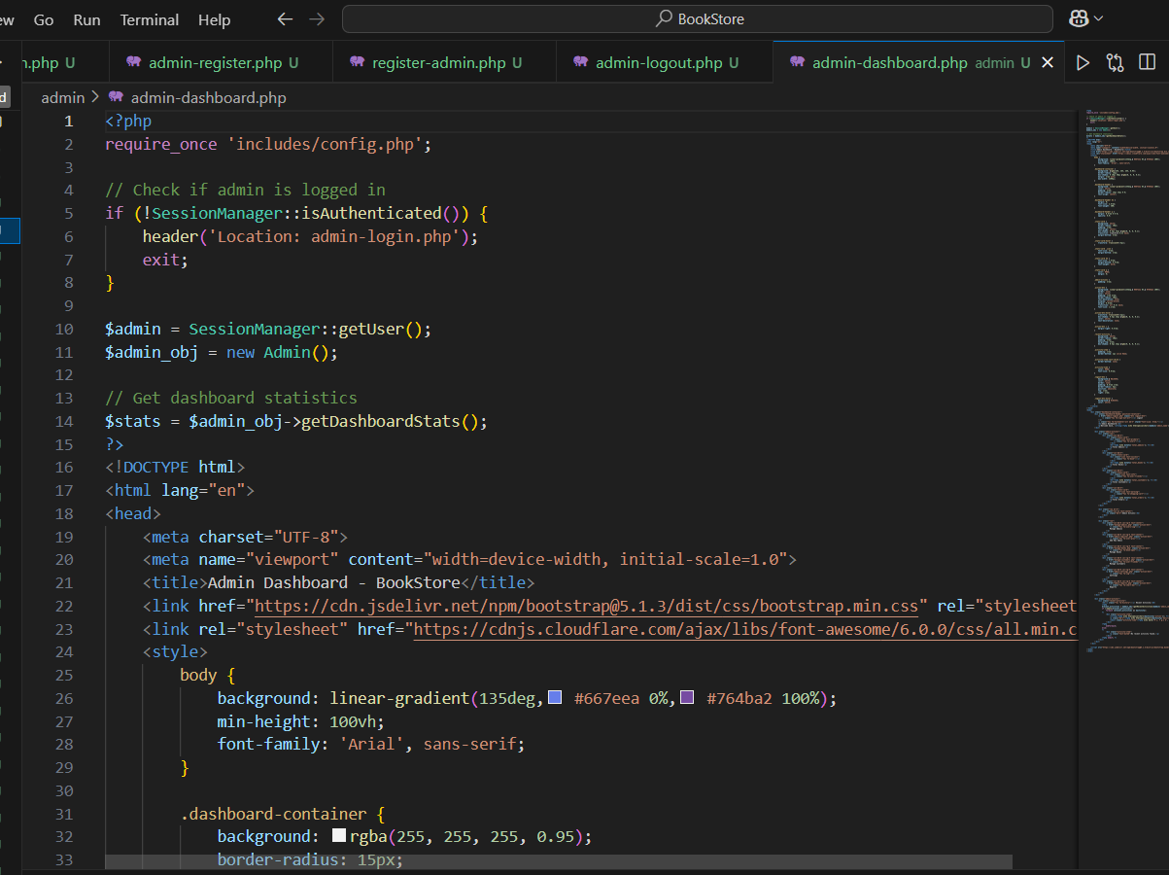

## Seller Interface

This is the login interface for the seller interface:

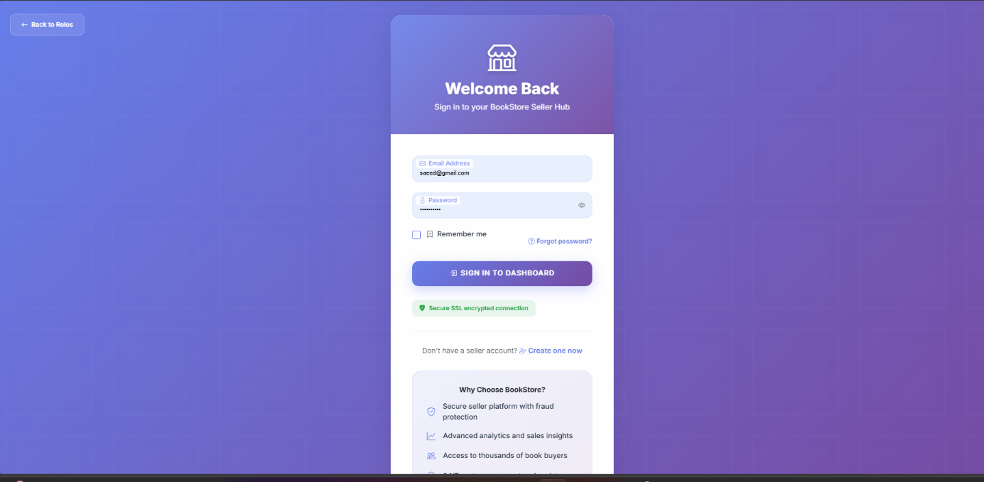If the user wants to reset the password, it is sent to this webpage:

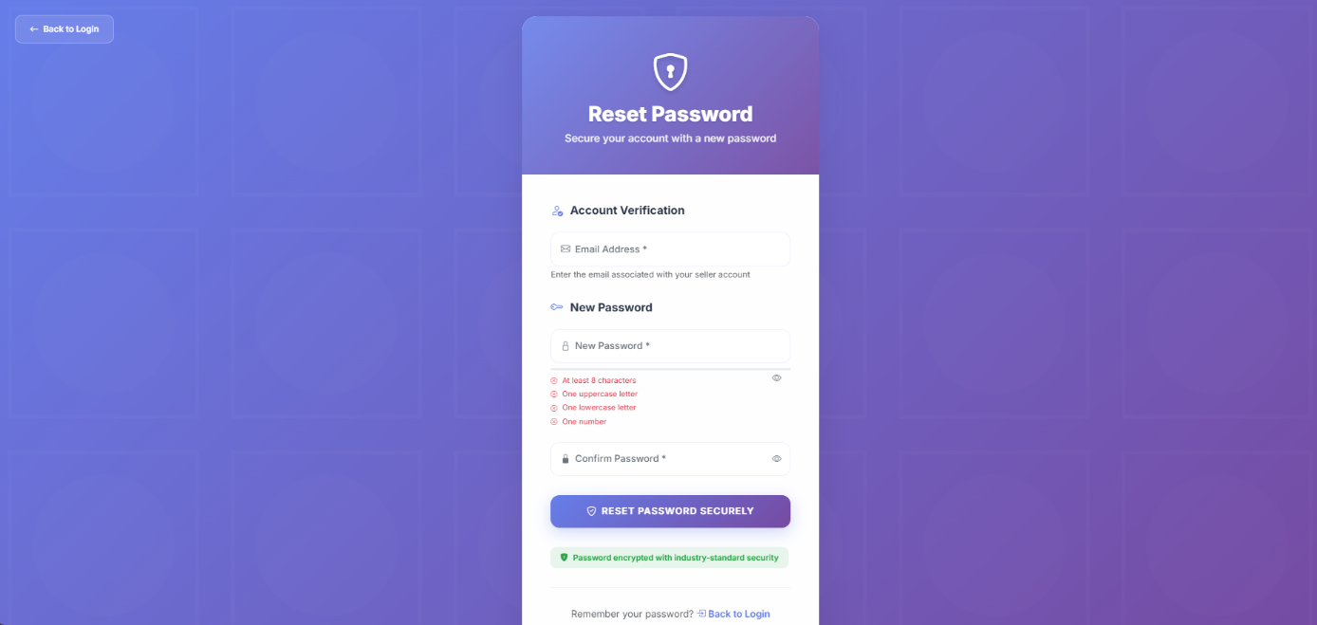

For registering, the seller has to enter some personal information:

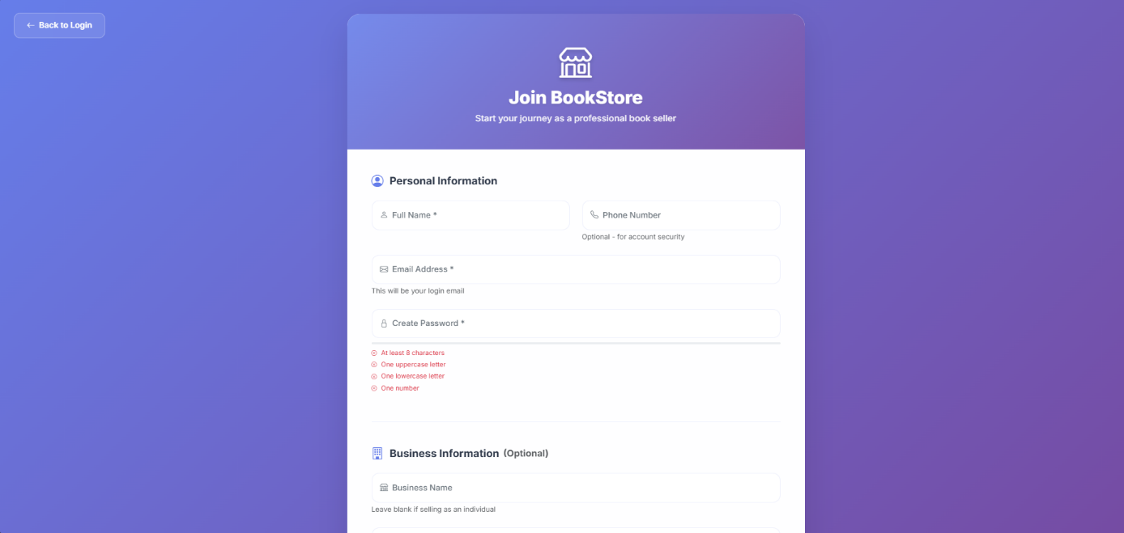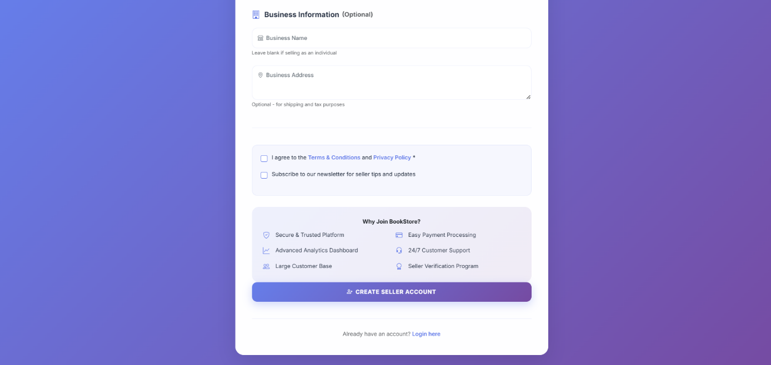

After successfully login, the seller ends up in this interface:

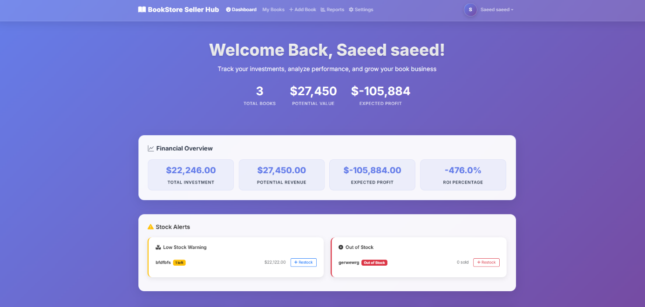

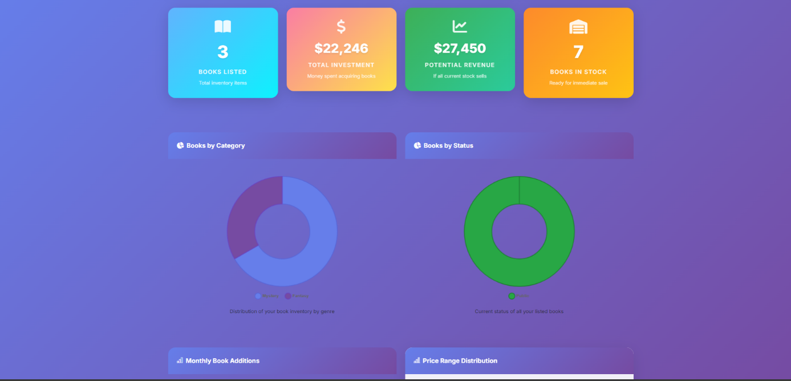

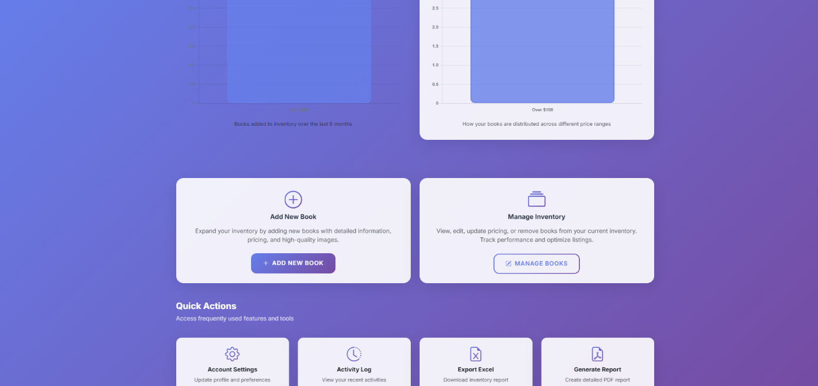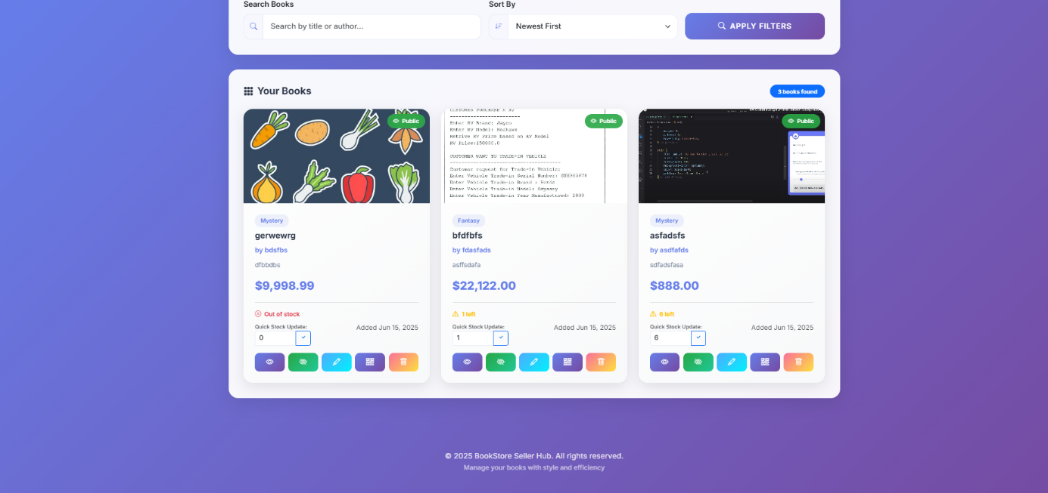

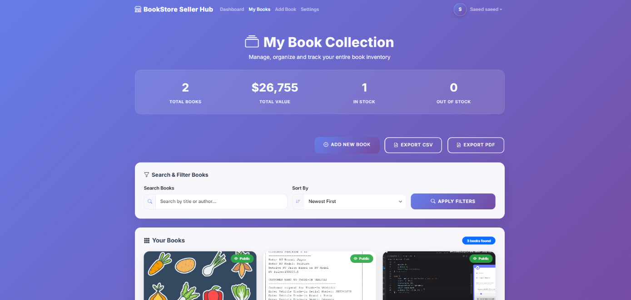

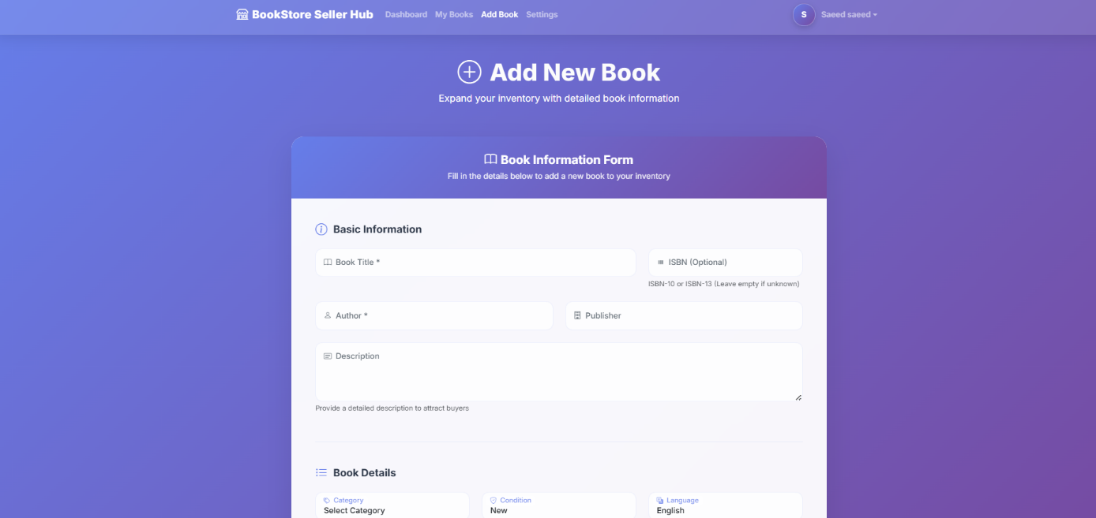

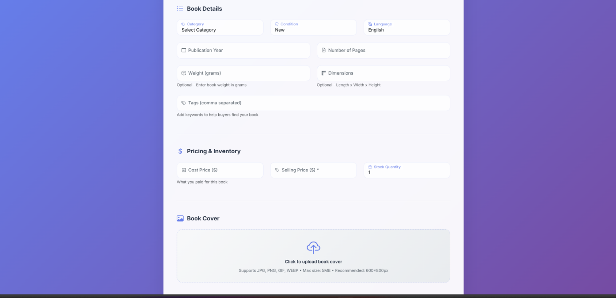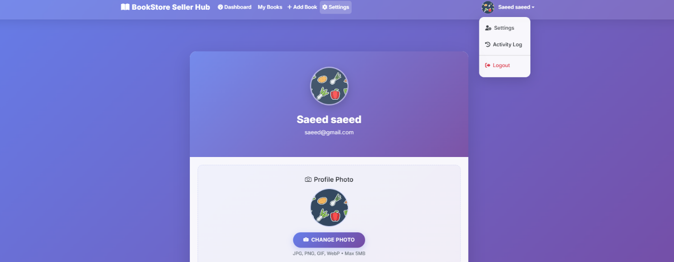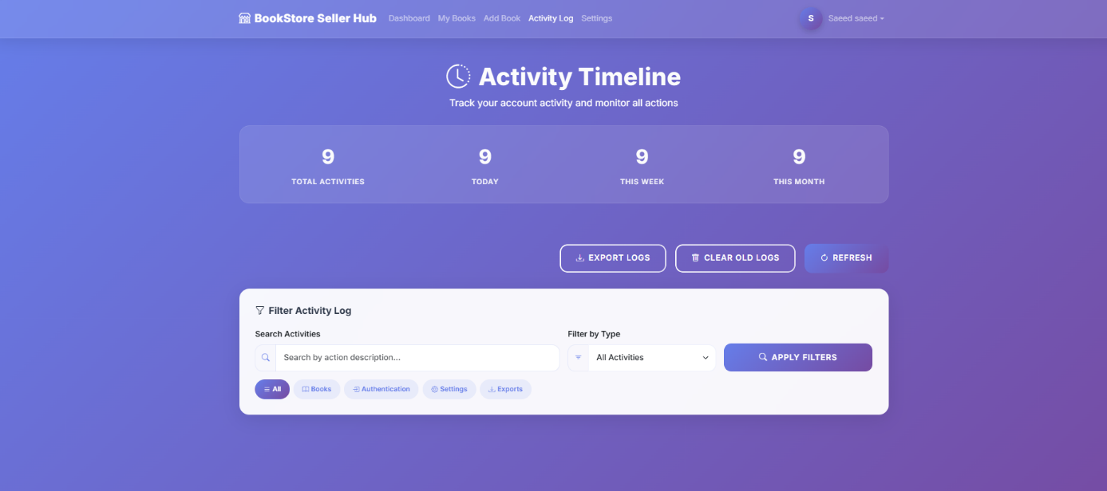

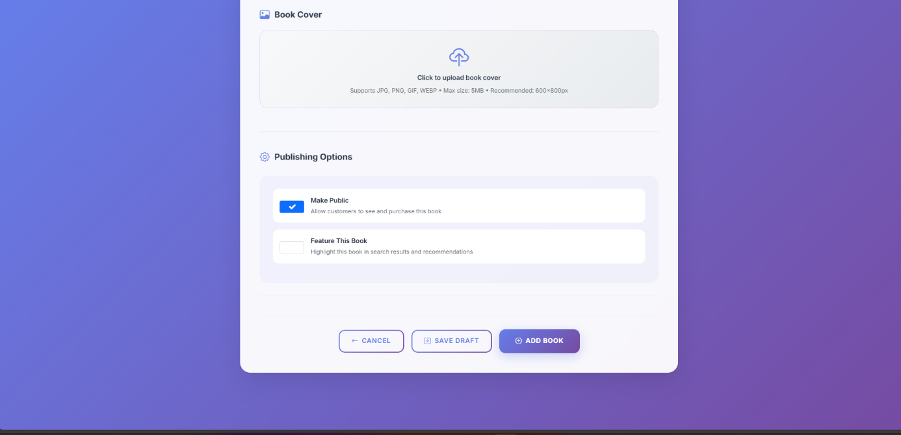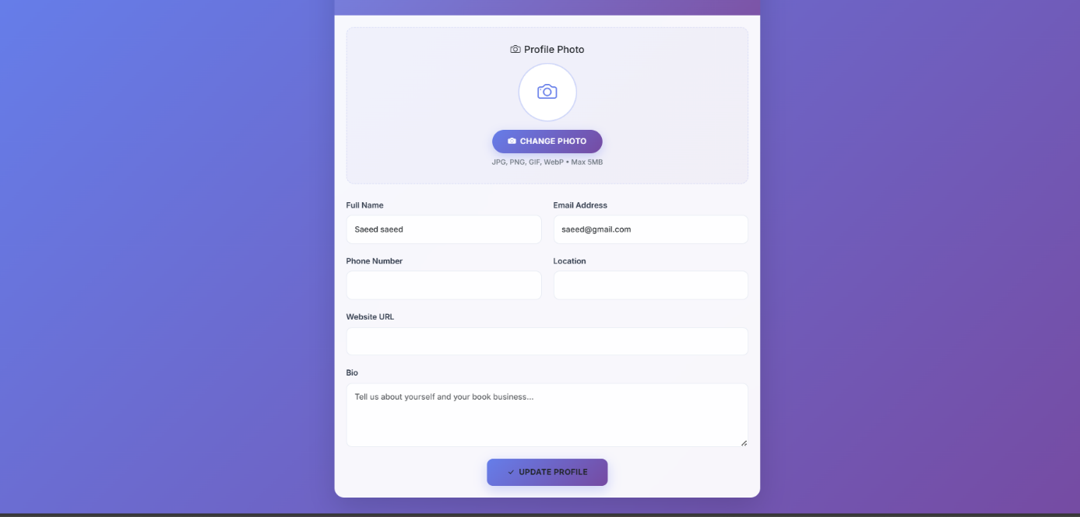

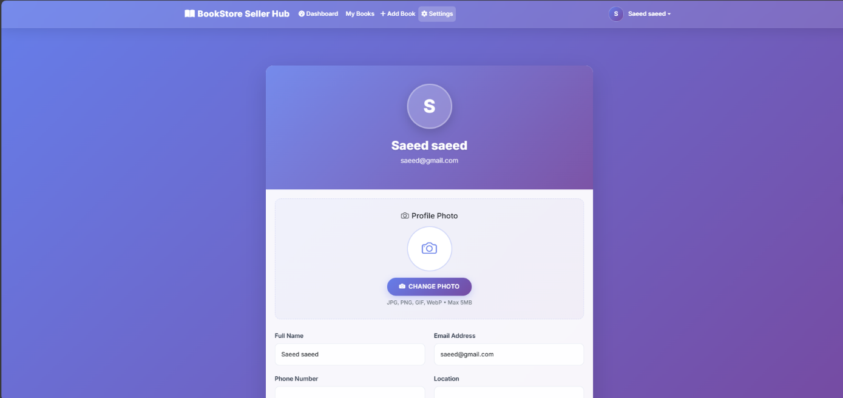

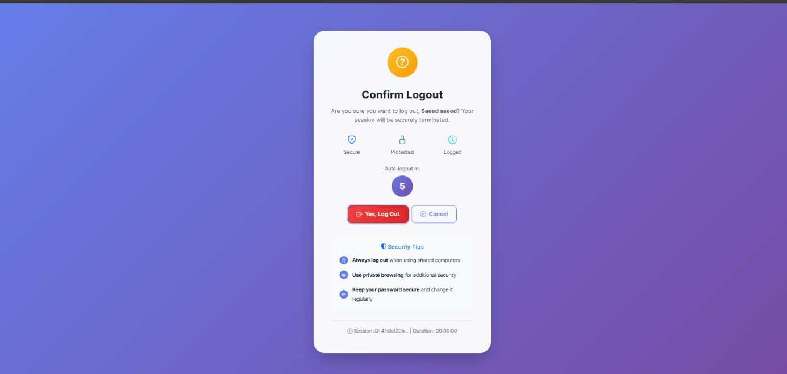

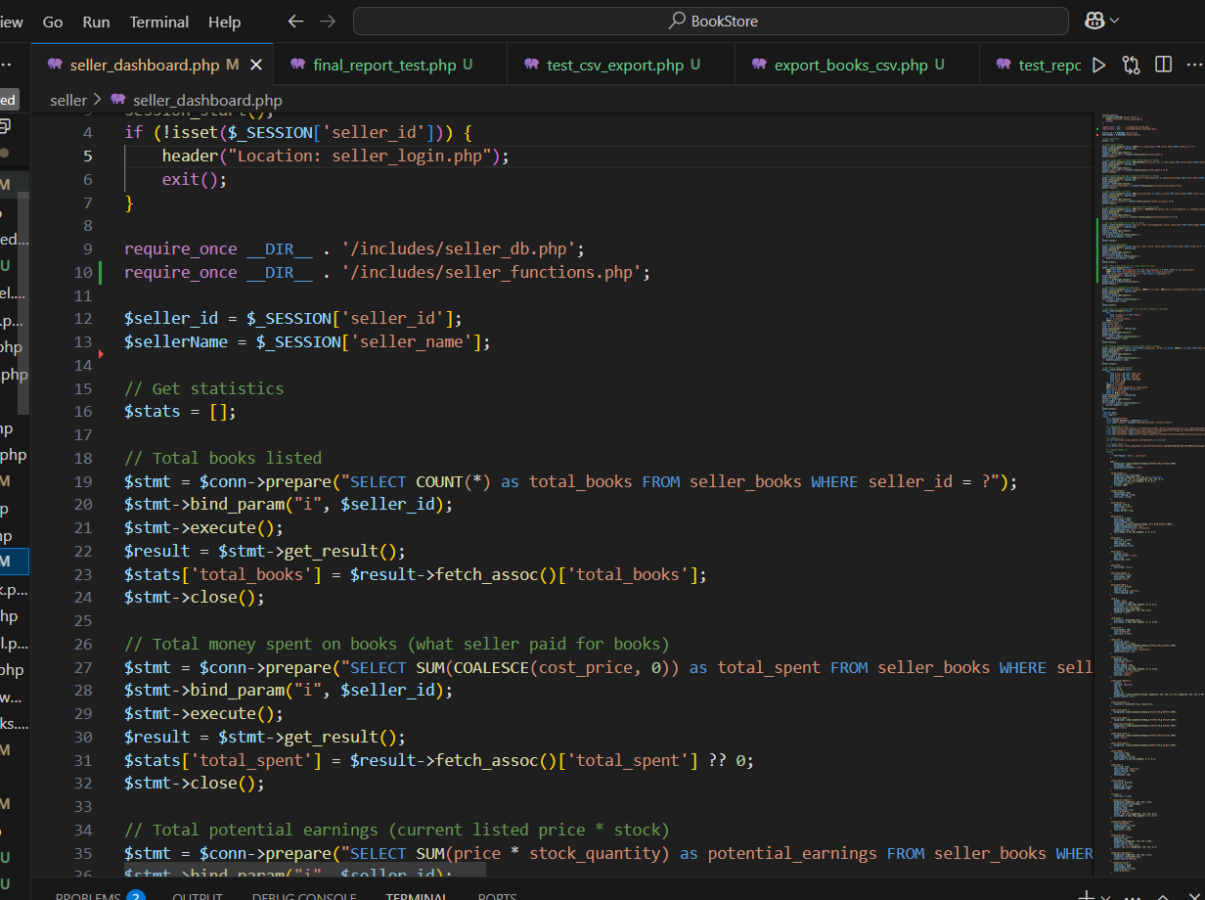

## Customer Interface

In order to create an account, the customer has to enter some information:

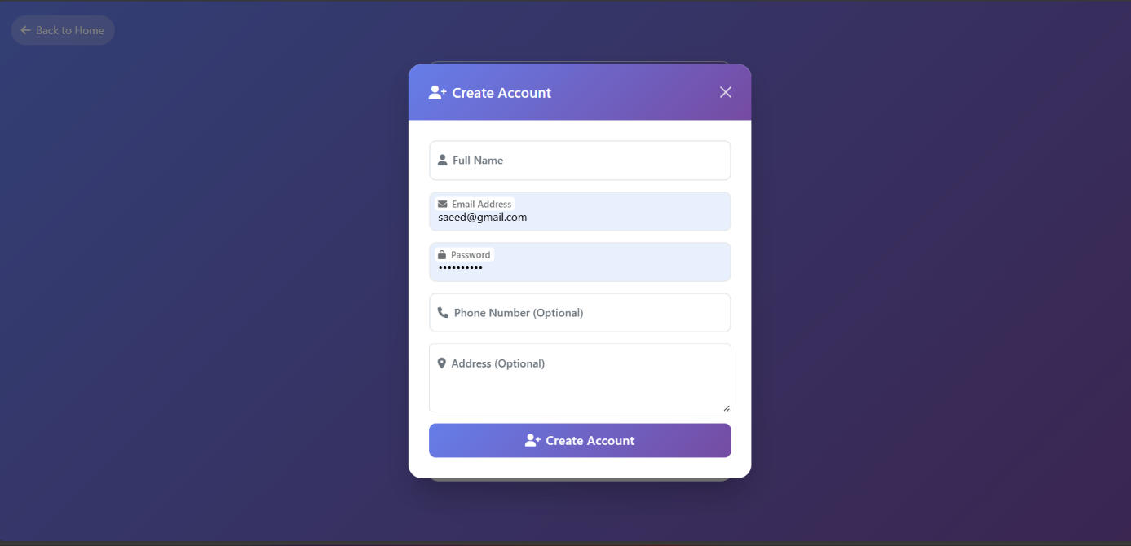

After successfully login, the customer ends up in this webpage:

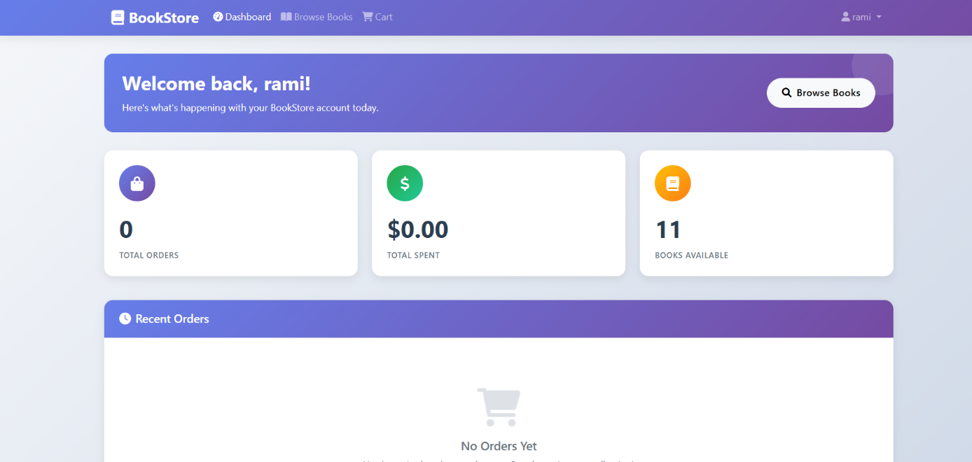

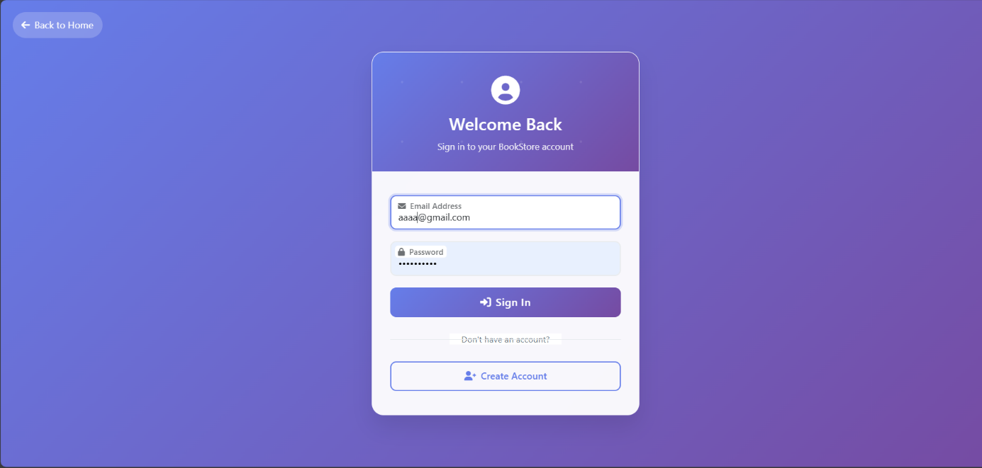

The customer can find the items that the seller has entered previously.

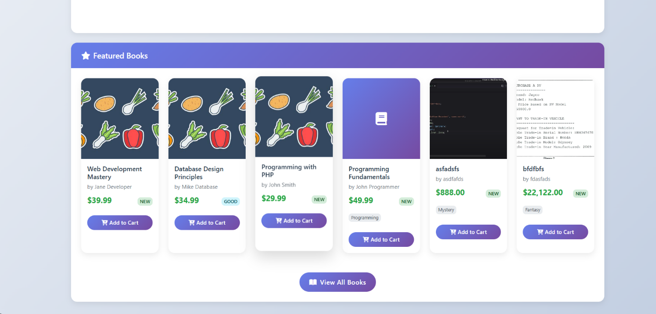

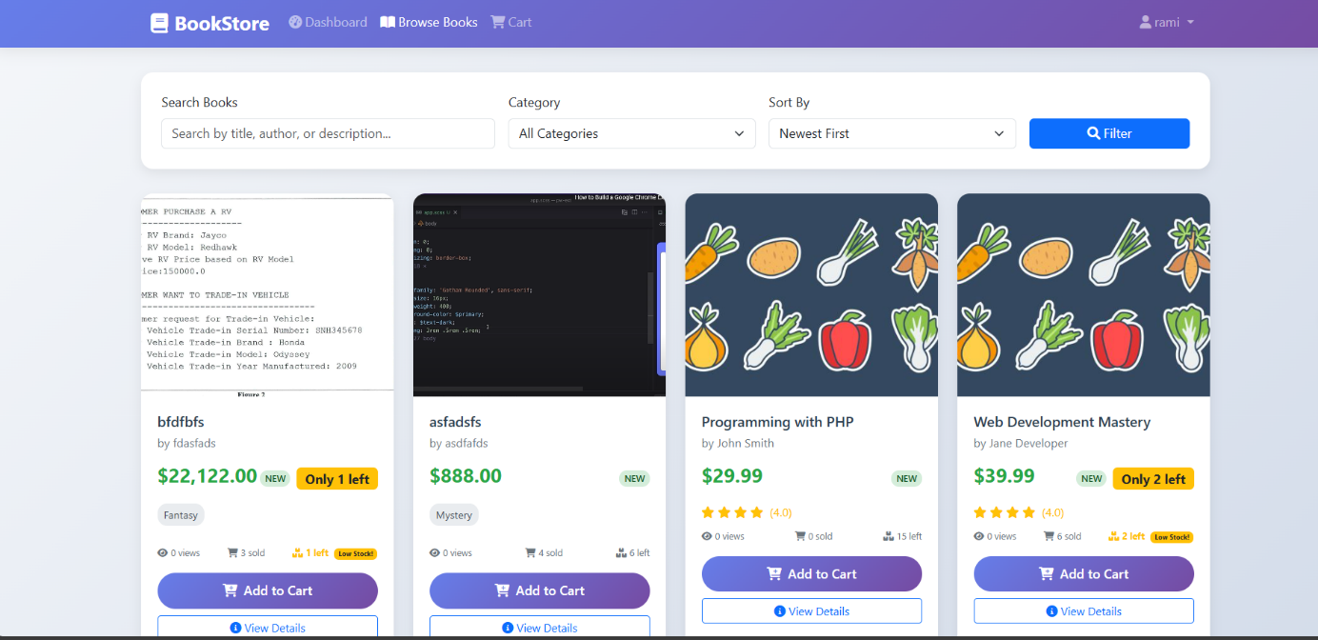

After adding the items to the cart, the customer can proceed to the payment.

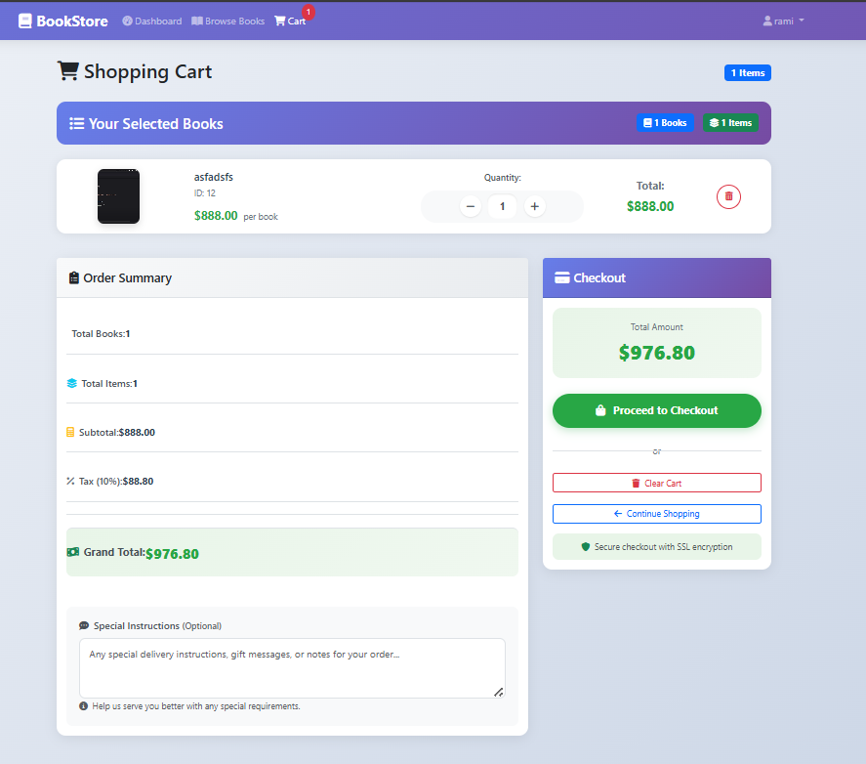

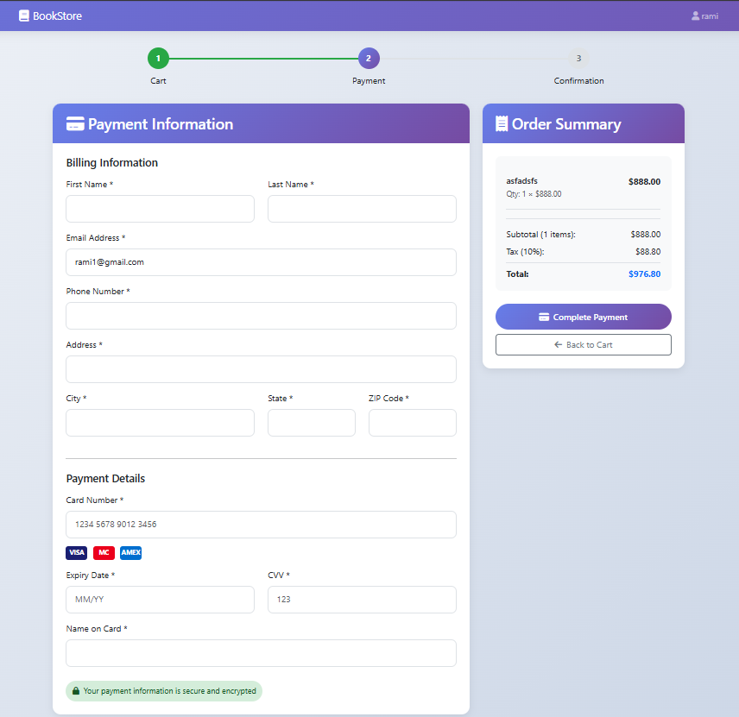

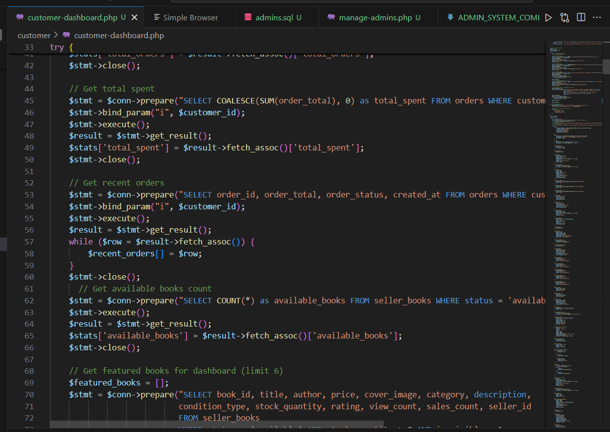

## Courrier Interface:

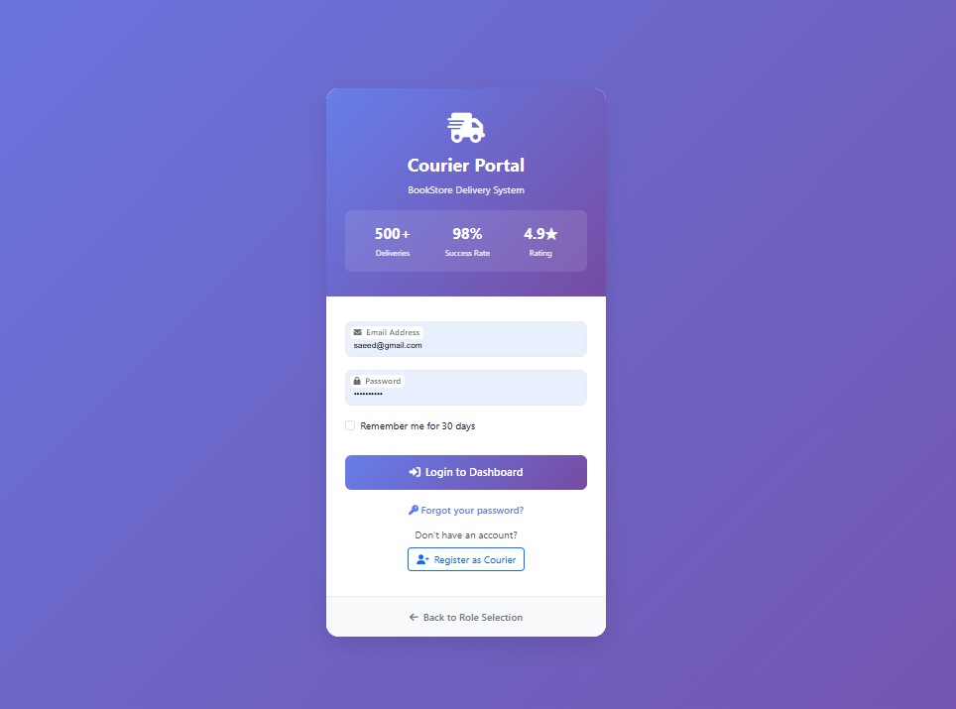

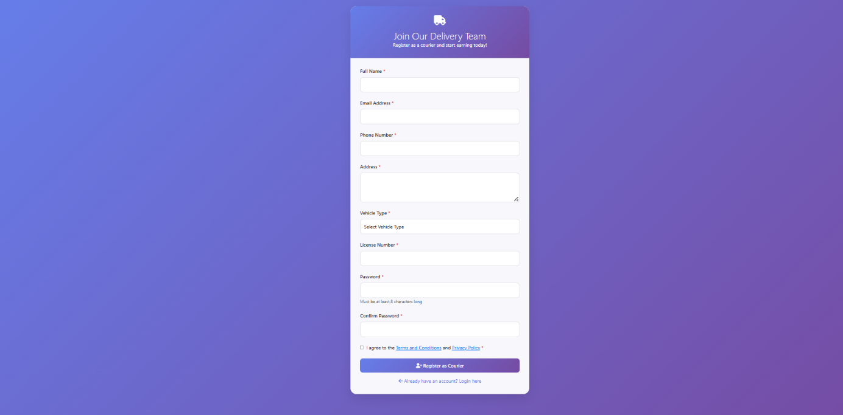

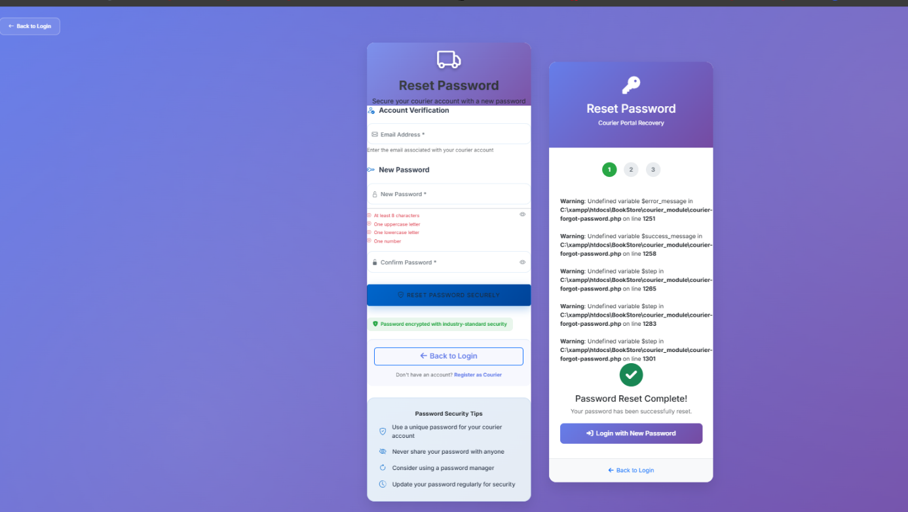

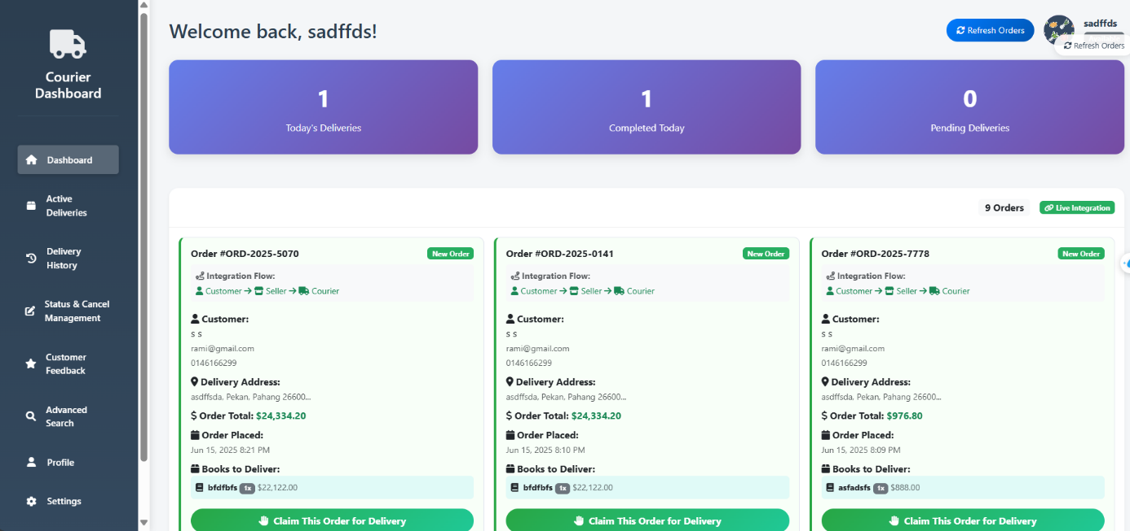

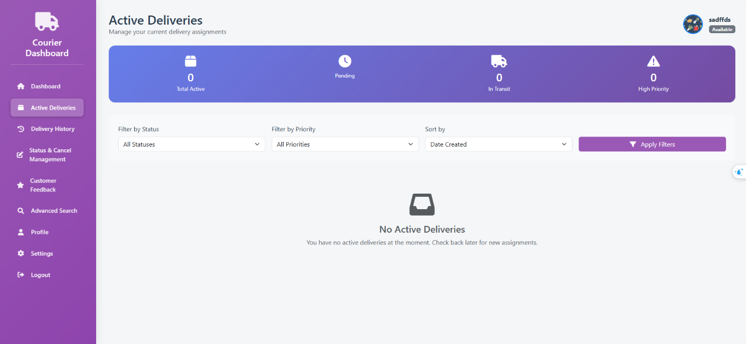

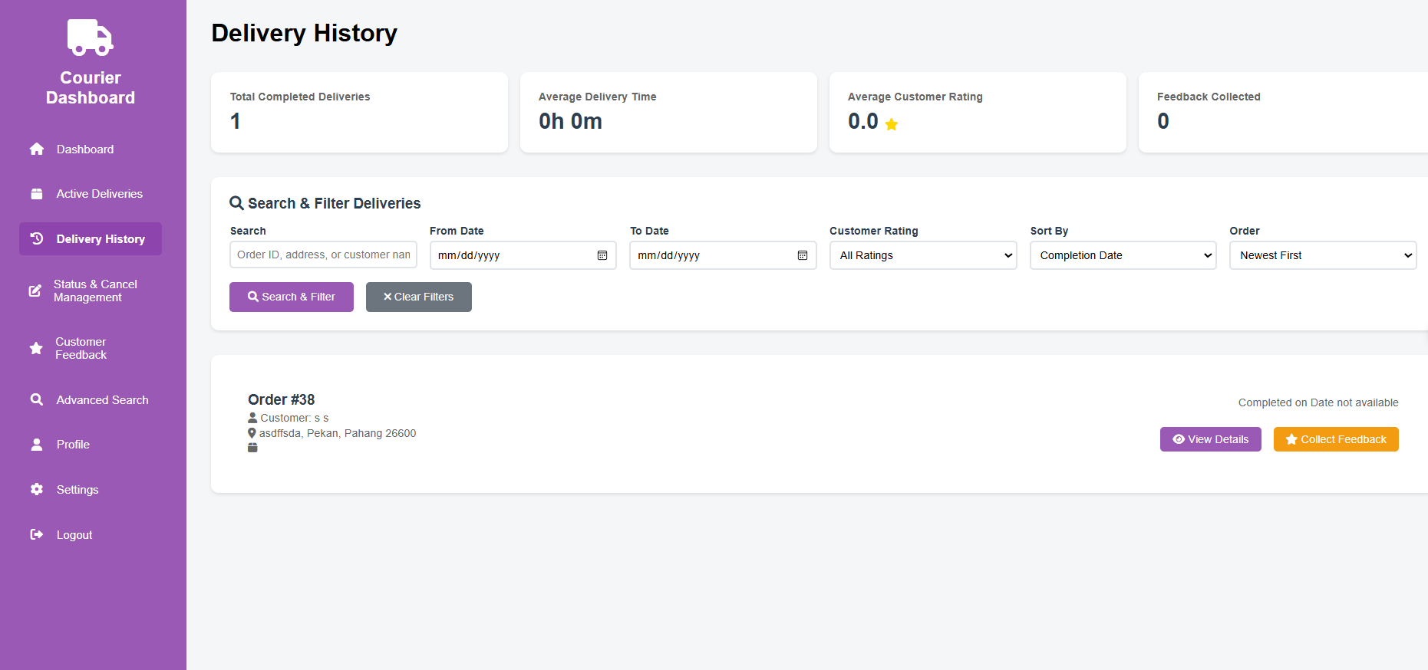

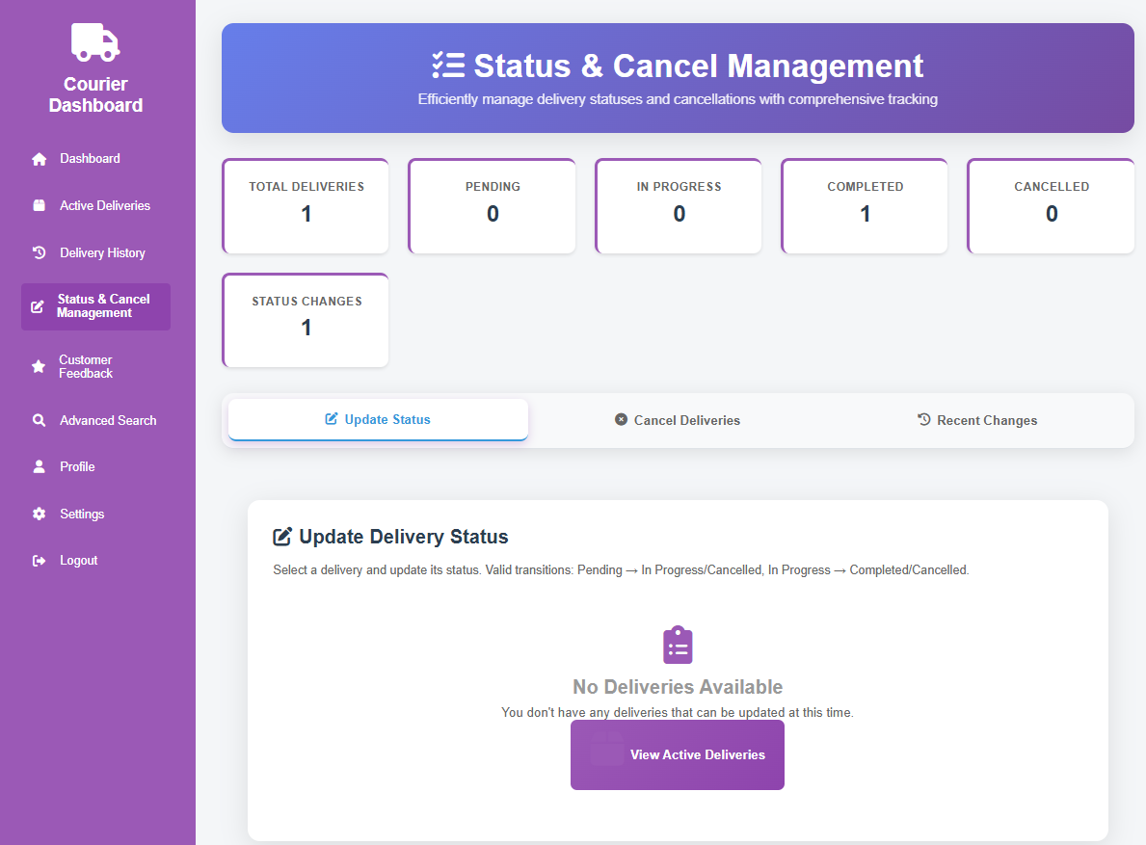

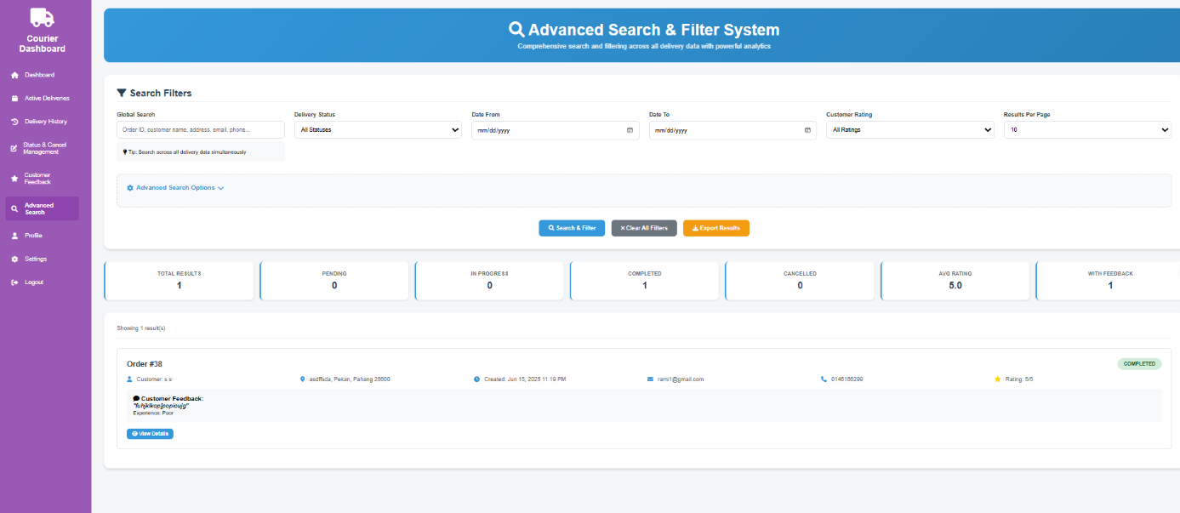

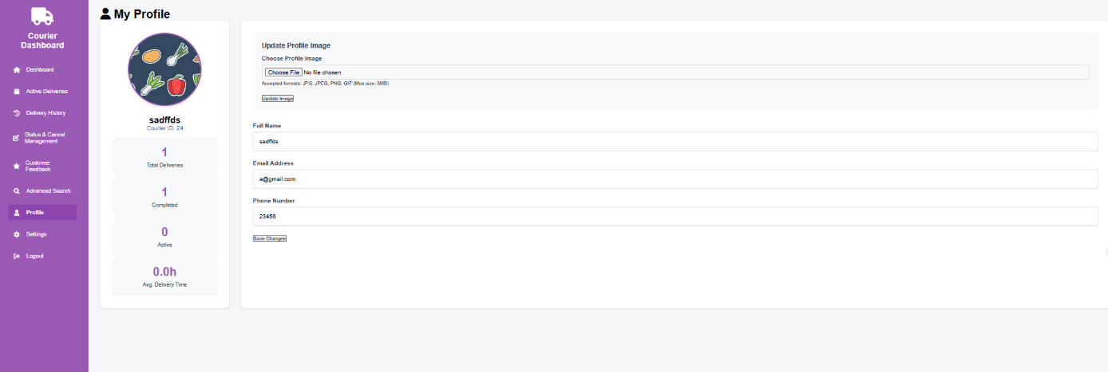

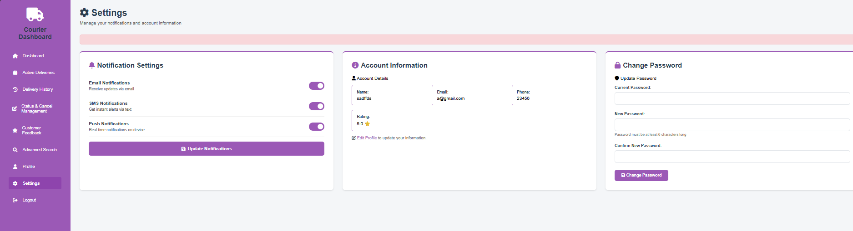

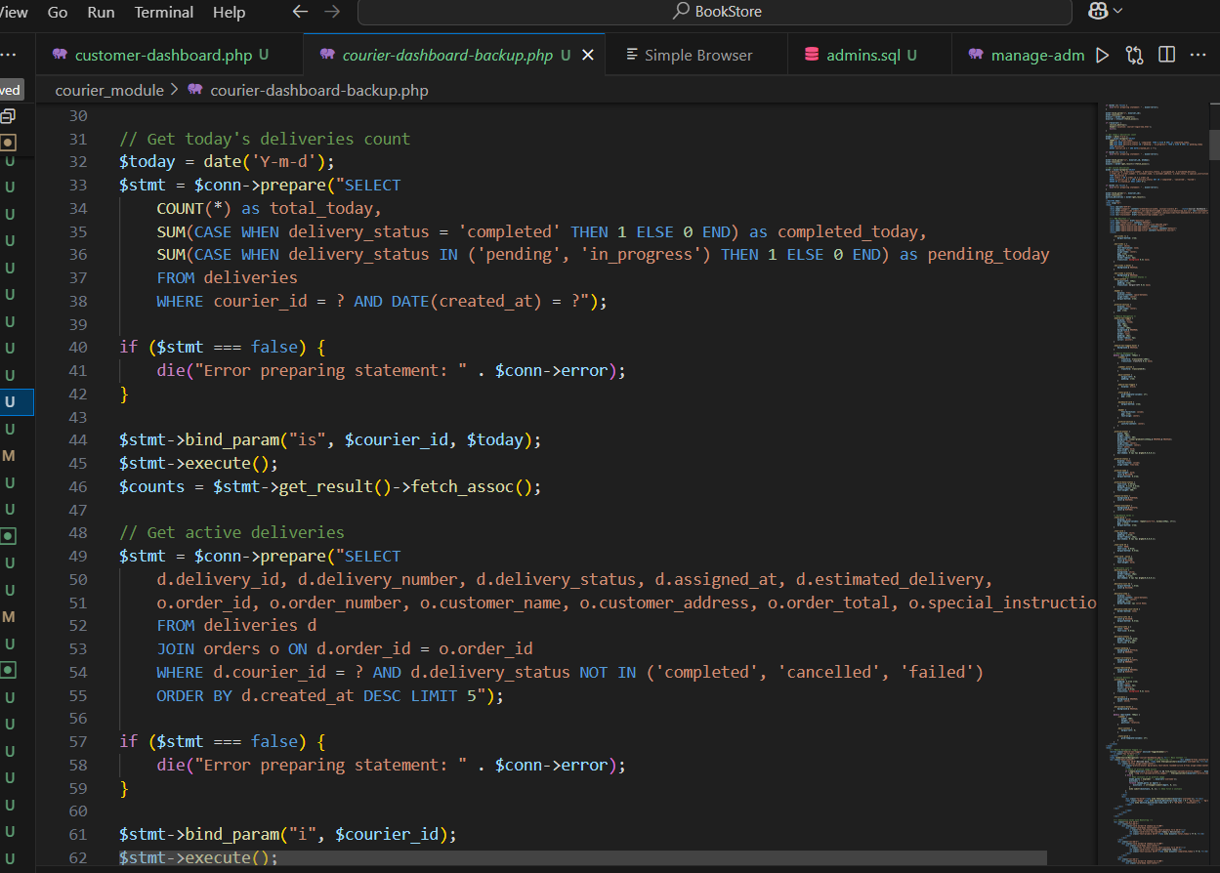

# INDIVIDUAL PLANNING

Student Name: **SAEED MOHAMMED KHALED ABDULAZIZ**

Matrix no.: **CF23006**

|  |  |
| --- | --- |
| Task no. | 1 |
| Task description | Design of Select Role website page |
| Planning | * Draft wireframe showing options like **Admin**, **Seller**, **Customer**, and **Courier**. * Use Bootstrap buttons or card components for clean role selection interface. * Link each role to its respective login/register or dashboard. * Ensure accessibility and responsiveness for different screen sizes. |
| Instructions for members of the group | * **Rami**: Design and create the front-end layout (HTML/CSS) with 4 clickable role boxes or buttons. * **AL-Mashgari**: Style the layout using Bootstrap and align the design with the site's overall theme. * **Saeed**: Add PHP functionality to redirect users based on role selection . * **Basaif**: Test the navigation functionality and ensure proper linking and responsiveness across devices. |
| Resources (e.g., references, time, template) | Bootstrap v5 Docs, FontAwesome Icons |

Student Name: **Almashgari Abdulrahman Saleh Salem**

Matrix no.: **CF23002**

|  |  |
| --- | --- |
| Task no. | 1 |
| Task description | Design the Courier Pages of the Website |
| Planning | * Survey:   Research well-designed courier dashboards and order management systems to gather ideas on functionality and design.   * Decide Types of Design:   Choose a clean, simple, and functional design for the courier interface.  Include sections like Order List, Order Details, and Status Update.   * Implement Design:   Develop the Courier Dashboard page, displaying orders with current status and a button to update delivery status.  Implement Order Details Page where couriers can view all relevant information (e.g., customer address, items, delivery status). |
| Instructions for members of the group | * Stick to the agreed-upon design template. * Make sure that all features are easy to use for couriers. |
| Resources (e.g., references, time, template) | * Use w3schools for HTML, CSS, JavaScript references for building the layout. * Refer to [Insert Design Inspiration Link or Template] for UI design elements. * Use Bootstrap for responsive design. * XAMPP for local server setup and testing the pages. |

|  |  |
| --- | --- |
| Task no. | 2 |
| Task description | Customer Form for Courier Information |
| Planning | Decide and Discuss with Group Members:   * Define the fields and data types required for the customer form that the courier will use for updating delivery status. This could include fields like Order ID, Customer Name, Delivery Address, Status, etc. * Plan how the customer information will be displayed for couriers to reference. |
| Instructions for members of the group | * Please use Customer table * Do not add any fields in the database without informing. * Primary key is Customer ID |
| Resources (e.g., references, time, template) | * Use XAMPP for setting up the MySQL database. |

|  |  |
| --- | --- |
| Task no. | 3 |
| Task description | Update and Manage Orders for Couriers |
| Planning | * Discuss and Define Fields: Work with the group to decide on the fields needed for the Courier Order Form. These may include Order ID, Customer Name, Delivery Status, and Update Button. * Design Table: * Set up a table to manage orders in the database, allowing the courier to update delivery status. * Design Form: * Build the form that allows the courier to change the status of each order (Pending → Delivered) and update it in the system. |
| Instructions for members of the group | * **Test all features thoroughly** before finalizing. * Report any bugs or issues for quick resolution. |
| Resources (e.g., references, time, template) | * PHP and MySQL CRUD Operations: * XAMPP * MySQL Documentation: |

Student Name: Basaif Ahmad Islam Ahmad

Matrix no.: CF23003

|  |  |
| --- | --- |
| Task no. | 1 |
| Task description | Design of the website |
| Planning | * Surveyed popular and modern bookstores web sites. * Chose on design elements that were relevant in a bookstore implement design. * Went through testing of the design both on devices and browsers to maintain consistency. |
| Instructions for members of the group | * Use the agreed UI components and color scheme for consistency * Avoid introducing new layouts without team discussion. * All pages must follow the same header/footer template. |
| Resources (e.g., references, time, template) | * Use w3schools. |

|  |  |
| --- | --- |
| Task no. | 2 |
| Task description | Admin form |
| Planning | * Discuss with team members on the fields that are needed: Full Name, Email, Password, Security Key * Choose suitable data type (e.g. varchar when it is name/email, int when it is a security key) * Create the admin table with primary key as the admin_id * Make a sign up form that connects to a database with PHP and MySQL * Validate inputs on both client and server side |
| Instructions for members of the group | admin table   * admin_id (primary key) * admin_name * admin_email * role * admin_password * security_key |
| Resources (e.g., references, time, template) | * XAMPP * PhpMyAdmin * <https://www.w3schools.com/php/php_mysql_intro.asp> |

|  |  |
| --- | --- |
| Task no. | 3 |
| Task description | admin form (continued) |
| Planning | * Implement the login functionality using the same admin table * Design a login form with input validation and user feedback * Redirect admin to a dashboard or homepage upon successful login |
| Instructions for members of the group | * Do not duplicate admin registration or login logic unnecessarily * Always hash passwords and never store them in plain text * Notify team before making changes to authentication flow |
| Resources (e.g., references, time, template) | * XAMPP * phpmyadmin * <https://www.w3schools.com/php/php_mysql_intro.asp> |

# Meeting Report (LOGBOOK)

**Meeting No:** Meeting #1

**Date**  **: 6/6/2025**

**Time**  **: 14:00**

**Venue** **: MS Teams**

**Chairperson : BENOUAHMANE RAMI**

**Attendees** **: All Members**

**Absent and Reason:**

|  |  |  |
| --- | --- | --- |
| **No** | **Agenda** | **Status/Action** |
| **1** | Introduction to the project. | No one was absent. The team discussed the project objectives and confirmed the final title. |
| **2** | Finalizing the project title from the shared Google Drive. | All the members were present. The title [Insert Title] was finalized. |
| **3** | |  | | --- | | Assigning roles and responsibilities for each team member. | | Roles were assigned: |
| **4** | |  | | --- | | Discussing the technologies and framework to be used (HTML, CSS, JavaScript, PHP, MySQL, Bootstrap). | | All the members were present. The group reviewed the completed features, including the UI and login system, and planned the next steps for data insertion and retrieval. |

**Photo of Meeting Session:**

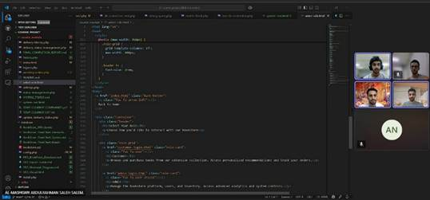

**Meeting No:** Meeting #2

**Date**  **: 10/6/2025**

**Time**  **: 15:00**

**Venue** **: Library**

**Chairperson : BENOUAHMANE RAMI**

**Attendees** **: All members**

**Absent and Reason:**

|  |  |  |
| --- | --- | --- |
| **No** | **Agenda** | **Status/Action** |
| **1** | Review progress on the project’s initial tasks. | All members were present. The group reviewed the progress on the homepage design and finalized the layout. |
| **2** | Finalize UI design and layout. | No one was absent. The UI design was successfully completed with a responsive layout using Bootstrap. |
| **3** | Discuss the implementation of the login system and database connectivity. | the team discussed how the login system will authenticate users with PHP and MySQL. |
| **4** | Plan the next steps for data insertion and retrieval from the database. | All members present. Discussed the need for creating forms to insert data into the database and retrieve user data for display. |

**Photo of Meeting Session:**

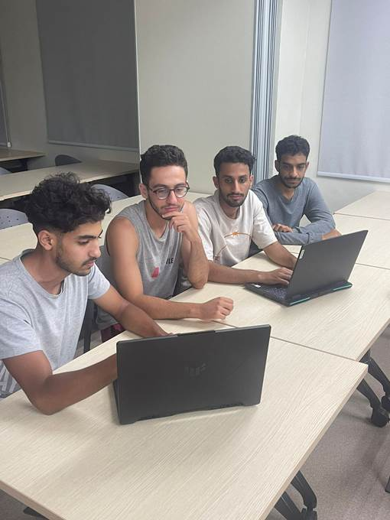

**Meeting No:** Meeting #3

**Date**  **: 13/6/2025**

**Time**  **: 15:00**

**Venue** **: MS Teams**

**Chairperson : BENOUAHMANE RAMI**

**Attendees** **: All members**

**Absent and Reason:**

|  |  |  |
| --- | --- | --- |
| **No** | **Agenda** | **Status/Action** |
| **1** | Review progress on UI and database functionality | All the members were present. The team reviewed the UI and database functionality. All core features are functional. |
| **2** | Finalize data insertion, update, and retrieval | The team finalized the data insertion and retrieval functionality. |
| **3** | Finalize data update and delete functionality | All the members were present. The data update and delete functions were successfully integrated and tested. |
| **4** | Plan for hosting and final deployment | All the members were present. Discussed different hosting options and selected the platform for deployment. |

**Photo of Meeting Session:**

Screenshot of Google Meet/Zoom/MS Teams etc.

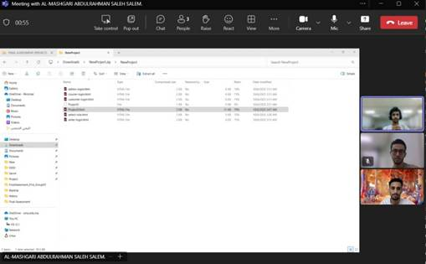

# Task Distribution:

|  |  |
| --- | --- |
| Name | Task |
| BENOUAHMANE RAMI | * Gantt chart * Database tables * Interfaces and codes * Individual planning |
| SAEED MOHAMMED KHALED ABDULAZIZ | * Proposed solutions * Database tables * Interfaces and codes * Individual planning |
| ALMASHGARI ABDULRAHMAN SALEH SALEM | * Objectives * Database tables * Interfaces and codes * Individual planning |
| BASAIF AHMAD ISLAM AHMAD | * Introduction * Database tables * Interfaces and codes * Individual planning |

Web Hosting

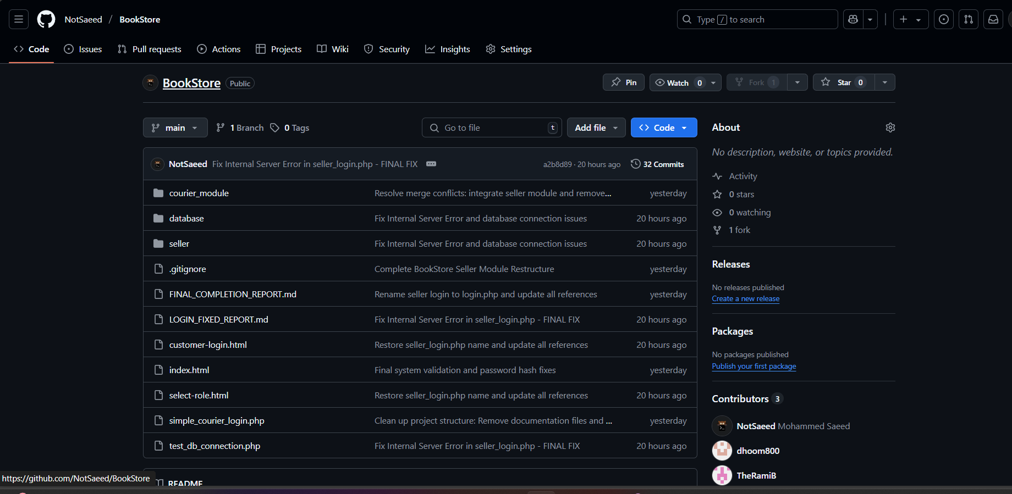

<https://github.com/NotSaeed/BookStore>